- Before you are enrolled in the Exercise and Education Program, the staff need to make certain that the program will be suitable for you.
Once enrolled, we understand there may be days you are unable to attend due to illness or other commitments. If this is the case, please contact us on insert contact # any day during the week.
If you are unable to attend a session, you can make up these days so that you can benefit fully from the program.
Please tell us if you are unable to attend a session. Due to the high demand for this program, if you miss two sessions in a row without letting us know, your position in the class may be allocated to another patient.

insert staff names and delegations
insert staff names and delegations
insert staff names and delegations
insert staff names and delegations

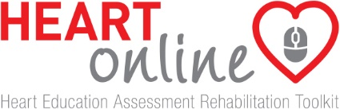

Insert service name and logo
Contact details
Phone: insert phone number
Fax: insert fax number

insert class days and times

Updated insert date

Insert name of service e.g. Heart care, Heart health, Heart recovery

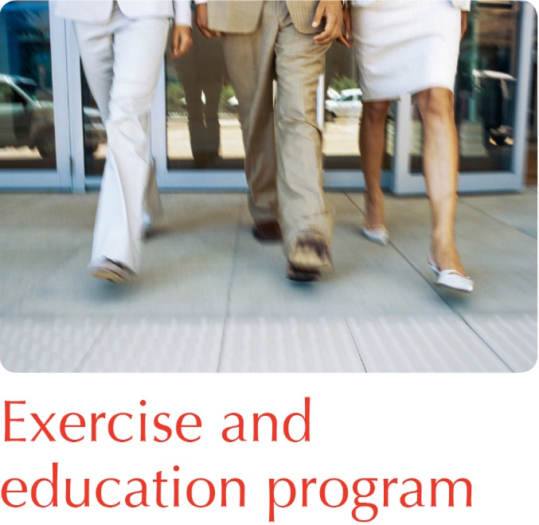

insert organisation name
Insert name of program e.g. Heart Health, Heart Care, Heart Recovery Rehabilitation Program
What is it?
The insert name of program offers support for patients and their families or carers to assist in achieving heart health.
Who provides the service?
The insert name of program comprises a insert professions: cardiologist, nurse, physiotherapist, exercise physiologist, pharmacist, dietitian, occupational therapist, social worker
When?
The program runs for insert number weeks and involves attendance for insert number sessions per week:
insert date and time
insert date and time
The session on insert 1st topic includes one hour of education and one hour of exercise while the insert 2nd topic session is exercise alone.
Where?
The exercise sessions are conducted in the insert location located insert directions
Why exercise?
Exercise has been proven to reduce symptoms of heart disease, increase quality of life, improve confidence and reduce the number of hospital readmissions.
What will I be doing?
The exercise classes consist of a range of exercises to improve your strength and fitness and include a gentle warm up and cool down. There are up to 10 participants in every class, supervised by the insert physiotherapist or exercise physiologist and nurse. Education sessions are provided by a variety of health professionals.
What do I bring?
Loose-fitting, comfortable clothing and suitable shoes (joggers) should be worn each time.
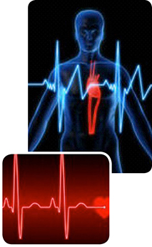
What happens when I finish the program?
Continuing to exercise after the program will ensure you maintain improvements and allow you to continue to progress. A maintenance program is available insert if you offer a maintenance program after you have completed the program.
There are also a number of community organisations that offer a variety of exercise opportunities. These include:
- Gym-based programs
- Group exercise classes
- Community walking groups
- Balance classes
- Tai Chi
More information on a suitable exercise venue near you can be obtained from on completion of the exercise rehabilitation program.
Will there be any follow up?
Your initial tests will be repeated when you complete the program, and at 6 and 12 months after completion. This allows you to monitor your progress and to seek advice relevant to your condition.

